Civil and Military Postal Censorship between the wars

Spanish Civil War 1936- 1939

Introduction:
1936 to 1939: A military rising originating in Morocco, headed by General Francisco Franco, spreads rapidly all over the country, thus starting the Spanish Civil War.
After a number of bloody battles in which fortunes changed from one side to the other, the 'nacionales' finally prevailed and made a victorious entry into Madrid (March 28th, 1939).
Very few events in modern European history have stirred popular imagination more than the Spanish Civil War (1936-1939). To this very day, an average person perceives the conflict as a struggle between "democracy" and "fascism." However, Arthur Koestler exposed this false dichotomy over forty years ago. This famous defector from Communism admitted that Soviet agents had supervised an intricate propaganda scam to endow with respectability the side supported by Stalin

Censorship: Censorship was imposed and all non-revolutionary parties and associations banned. The Soviet-style secret police ruled the realm. People were arrested for the "bourgeois" and "reactionary" custom of wearing crosses or coats and ties. Political prisoners were massacred. To stem the revolution, the failed military coup became an insurgency. In light of these events, it is more correct to speak of revolutionaries and insurgents than "democrats" and "fascists." Both the Republican side and the Franco side used postal censorship.

International Brigades:
A total of 59,380 volunteers from fifty-five countries served during the Spanish Civil War. This included the following: French (10,000), German (5,000), Polish (5,000), Italian (3,350), American (2,800), British (2,000), Canadian (1,000), Yugoslavian (1,500), Czech (1,500), Canadian (1,000), Hungarian (1,000) and Scandinavian (1,000). These men were organized into the 11th, 12th, 13th, 14th and 15th of the Mixed Brigades. About 500 Swedes were fighting on the Republican side of the war. The casualties of these Swedes was high, over 126 were killed in the fights.

1937: The year 1937 was characterized by fighting in the north of the country: Guernica was bombed in April, Bilbao taken in June, Santander in August, and Gijon in October. The reaction of the Republicans was to open fronts in Guadalajara (March),Brunete (July), and Belchite (August). The Battle of Teruel was launched at the end of the year. Barcelona was held by the Republicans.

Covers:
The following cover was sent from Lidingö, Sweden to Barcelona 1937-09-17. It was censored in Barcelona by the Spanish Government, the Republican Forces, not the Franco side or the Nationals. The large rectangular mark REPUBLICA ESPAÑOLA CENSURA measures 90x15 mm and is only know in violet colour.
The censor mark was used by the Republican Forces in Barcelona from August 1936 to October 1937. The No. “68” on the cover is evidently what Heller designates RB1.12 known 1937-1938.
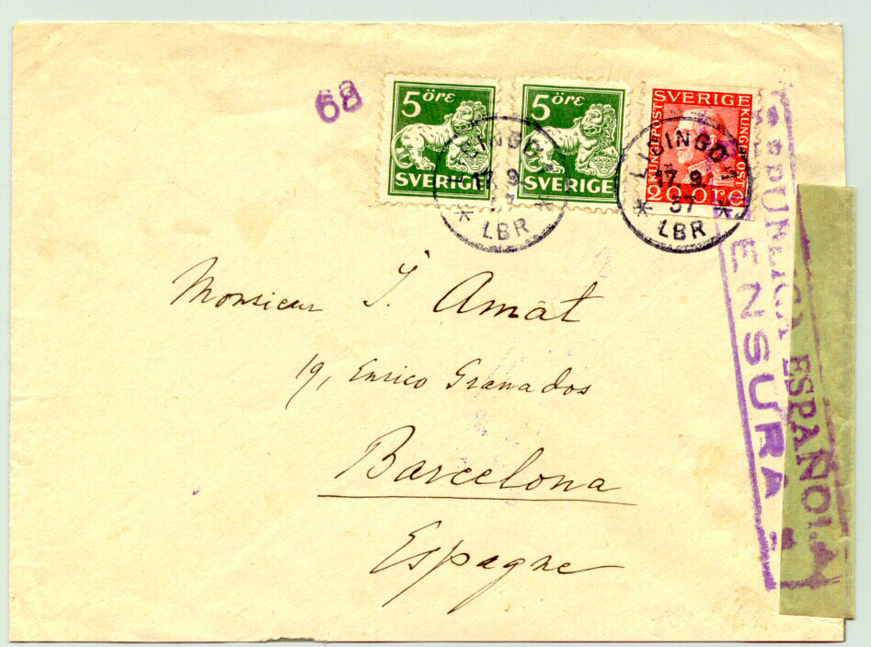
Front side of the censored cover franked with 30 öre coil stamps.
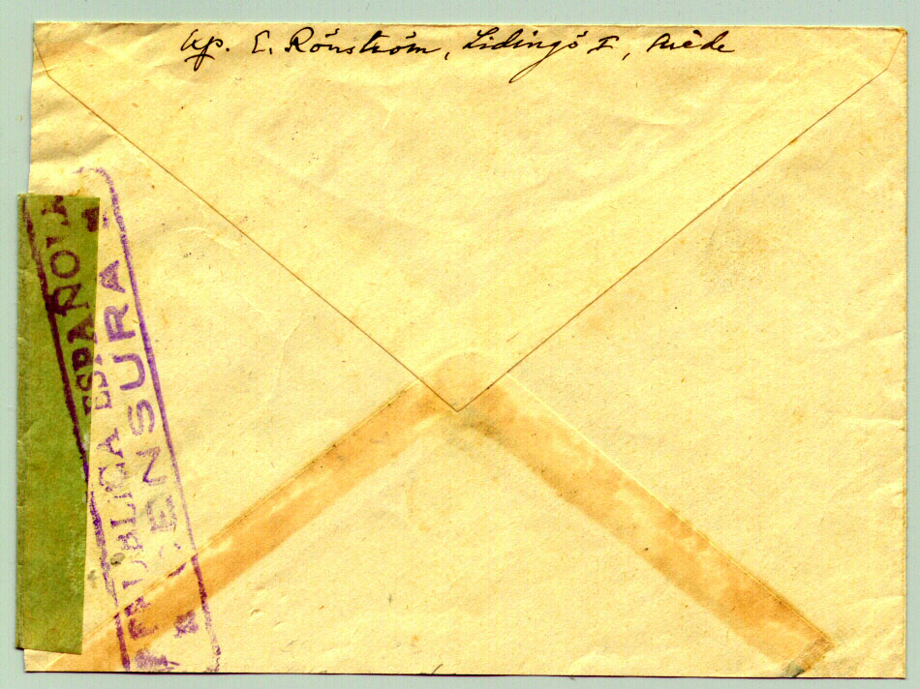
Reverse side of the cover above censored with the same rectangular censor stamp REPUBLICA ESPAÑOLA, CENSURA.

Literature:
Marcas utilizadas por la Censura Postal Nacional de 1936 a 1945, by Ernst J. Heller, issued 2000 in Zaragoza. 547 pages, Editorial: Filatelia Hobby, ISBN 89493171701. Price EUR 30,00 Postage EUR 5,60 = USD 44.20 Available at Casa del Libro, Site: http://www.casadelibro.com Address: Gran Vía, 29, ES-280 13 Madrid, Spain, Fax. 0034- 91 522 77 58 e-mail: casadelibro@casadelibro.com

THE POSTAL HISTORY OF THE INTERNATIONAL BRIGADES IN SPAIN 1936-1939 by R. Shelley, 2000, S/B, 184pp. Spanish Bookclub No. 11. A comprehensive handbook relating to the posts of the International Brigades during the Spanish Civil War. Thorough coverage of the postal services, information regarding Medical and Prison Mail. Short sections also cover memorabilia, commemoratives & foreigners in Republican Spain’s Air Force. Illustrated in black & white. £25.00 = USD 46.50 (Postage not included). Available at Vera Trinder Ltd, Philatelic Bookshop, 38, Bedford Street, Strand, London WC2E EU, U.K. e-mail: vera@trinder.co.uk
A GUIDE TO THE POSTAL HISTORY OF THE SPANISH CIVIL WAR 1936-1939. Ed R. Shelley, (Looseleaf contained in 2 binders), Spanish Bookclub No. 16. A scarce complete series detailing the Spanish Civil War and areas of its postal history, including the Republican and Nationalist Sectors, foreign intervention, colonies, and World War II. Well illustrated in black & white. £90 net. = USD 167.40 (Postage not included).
. Available at Vera Trinder Ltd, Philatelic Bookshop, 38, Bedford Street, Strand, London WC2E EU, U.K. e-mail: vera@trinder.co.uk

Contribution by Lars Lindblad, secretary and webmaster of SMPS, Swedeish Military Postal Histoy Society, pop4827@tiscali.se

